UXP-HTML5-L2-0001: User Registration Form

Level: L2

Technologies: HTML5, Css3, Bootstrap**.**

**Case Study – HTML User Registration Form**

Visual:

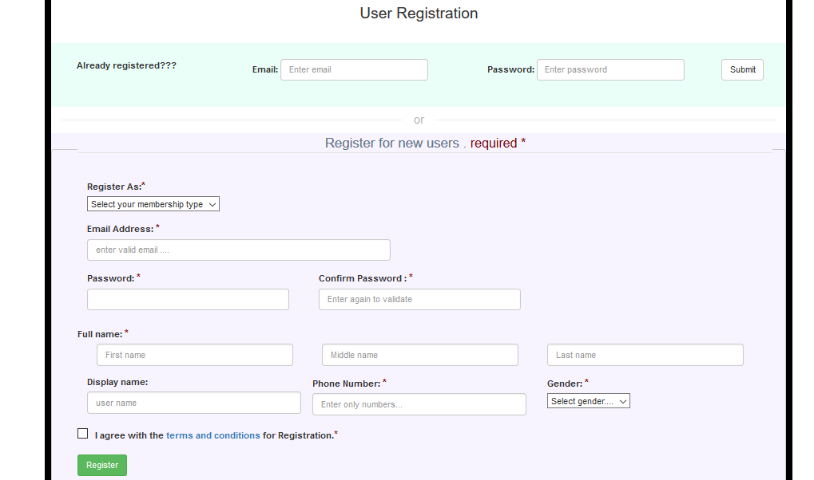

Figure Main page



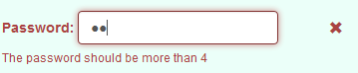

Figure Login form validation

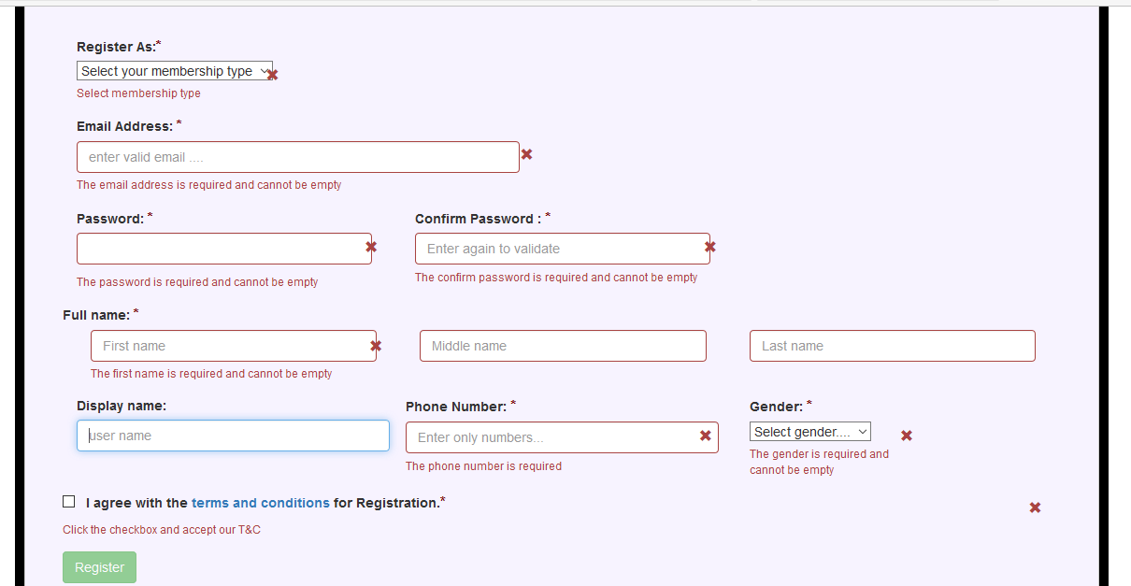

Figure Registration form validation-1

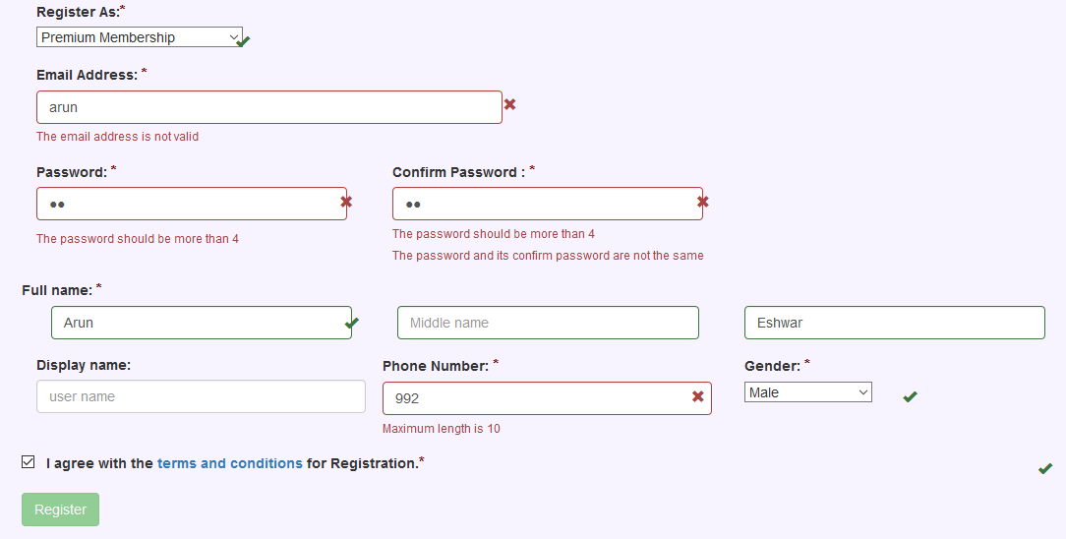

Figure Registration form validation-2



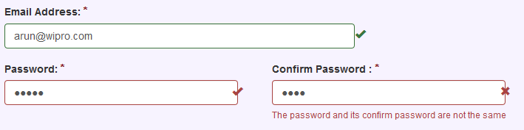



Figure Registration form validation-3